INTRODUCTION

Woody plants play an important role in determining the physical structure of many riparian ecosystems (Gurnell, Bertoldi & Corenblit 2012). Understanding the responses of woody riparian plants to environmental stresses is therefore central to river rehabilitation and riparian conservation efforts.

To thrive near stream channels, plants must navigate a trade-off between ease of access to water and stresses associated with waterlogging or inundation (Naiman, Decamps & Pollock 1993; Colmer & Voesenek 2009). Woody colonists of inset channel features such as bars and benches may experience repeated cycles of soil waterlogging (Corenblit *et al.* 2009), restricting root access to oxygen (Voesenek & Bailey-Serres 2015). Maintaining root respiration in low O2 conditions requires switching to costly anaerobic metabolic pathways (Drew 1997). Reduced respiration weakens root function, impairing uptake of water and nutrients (Piedade *et al.* 2010; Voesenek & Bailey-Serres 2015), and induces suberisation (Steudle 2000). Stomatal closure may also take place following waterlogging, reducing available CO2 for photosynthesis (Kozlowski 1984; Else *et al.* 2009). Root-zone hypoxia damages roots by disrupting aerobic respiration and causing an “energy crisis” (Colmer & Voesenek 2009); reactive oxygen species (ROS) then form as bi-products of anaerobic metabolism (Santosa *et al.* 2007), and subsequent re-aeration further increases ROS production (Steffens, Steffen-Heins & Sauter 2013). Production of toxic ions by microbes under anoxic soil conditions causes additional stress to roots (Blom & Voesenek 1996). Waterlogging may also impair rhizomicrobial nodule formation and activity, resulting in reduced nutrient uptake (Dawson, Kowalski & Dart 1989; Shimono *et al.* 2012). The degree to which this combination of stressors influences plant growth is ultimately determined by species’ ability to mobilise physiological and morphological responses which mitigate damage (Bailey-Serres & Voesenek 2008).

Atmospheric CO2 has risen substantially over the past century, and a doubling of pre-industrial levels by 2100 is projected (IPCC, 2013). As with waterlogging, atmospheric CO2 concentration is known to affect plant physiology and growth by altering the fundamental economics of carbon, water and macronutrient uptake and use (Poorter & Navas 2003; Wang *et al.* 2012; Reich, Hobbie & Lee 2014). Individual species responses are variable, but photosynthetic CO2 assimilation in C3 plants tends to increase under elevated CO2 (eCO2)(Curtis 1996). Stomatal conductance is also typically reduced (Ainsworth & Rogers 2007), with attendant gains in water use efficiency (Holtum & Winter 2010; Keenan *et al.* 2013; van der Sleen *et al.* 2014). Biomass accumulation in response to eCO2 may be enhanced (Wang *et al.* 2012), but this depends on the availability of water and macronutrients (Körner 2006; Manea & Leishman 2014; Reich *et al.* 2014). Increased allocation of biomass to roots occurs under eCO2 (Nie *et al.* 2013) and this effect is interactive with environmental stresses such as drought or low soil fertility (Wang & Taub 2010). Increased rates of production and turnover of fine roots under eCO2 have been shown in the field, which has important implications for nutrient cycling and ecosystem functioning (Pregitzer *et al.* 1995, 2000; Matamala & Schlesinger 2000; Lipson *et al.* 2014). eCO2 is also known to affect functional traits indicative of positions along economic spectra (*sensu* Reich 2014). Reduction in specific leaf area (SLA) under eCO2 may be linked to accumulation of non-structural carbohydrates in leaves (Poorter & Navas 2003; Bader, Siegwolf & Körner 2010). Alteration of traits reflecting economic trade-offs is of particular significance at the seedling stage, as functional traits of trees are most strongly adapted to the regeneration niche (Poorter 2007).

Taken individually, waterlogging and elevated atmospheric CO2 concentration appear likely to exert opposing effects on plant growth. The possibility that eCO2 may mitigate growth reduction under waterlogging warrants investigation of the interactive effects of these two important environmental variables. Literature describing interactive effects of atmospheric CO2 concentration and waterlogging or flooding on plant growth is sparse, and findings thus far present an inconsistent picture. eCO2 stimulated biomass production in waterlogged (water table at -10 cm) but not inundated (water table at +5 cm) juveniles of the flood-tolerant tree species *Taxodium distichum* (Megonigal, Vann & Wolf 2005). Increased photosynthesis under eCO2 was not reduced by inundation. This effect was attributed to the increased metabolic cost of maintaining roots under low O2 conditions. In the same study, inundation had no effect on eCO2 stimulation of photosynthesis or biomass production of the aquatic herbaceous species *Orontium aquaticum*. The opposite response was found for a highly flooding tolerant Amazonian tree: waterlogged *Senna reticulata* grown in open top chambers showed greater increment in biomass under eCO2 (Arenque *et al.* 2014). Finally, no evidence for an interaction between CO2 concentration and waterlogging status was found on growth or stomatal conductance in soybean (Shimono *et al.* 2012). To our knowledge, no studies have investigated the effects of eCO2 on recovery from waterlogging. Ability to recover following stress events may be a better indicator of fitness than tolerance of the stress (Gutschick & BassiriRad 2003), and for waterlogged plants, generation of reactive oxygen species following re-aeration is likely to be a significant additional stress (Drew 1997).

The objective of this study was to investigate interactive effects between eCO2 and waterlogging on gas exchange, biomass accumulation and allocation, and functional traits for riparian tree species. In particular, we were interested in whether eCO2 mitigated growth reduction under waterlogging, and whether this response was sustained following a refractory ‘recovery’ period during which soils were re-aerated. We also investigated two hypothesised mechanisms by which such an interactive effect might occur: a.) higher water use efficiency under eCO2 (Holtum & Winter 2010) facilitates photosynthesis in plants with anoxia-impaired root functionality by lowering the water cost of carbon assimilation; b.) eCO2 facilitates biomass recovery by increasing the rate of fine root production during the recovery period (Pregitzer *et al.* 1995).

METHODS

We selected three riparian tree species native to south-eastern Australia for this study. *Casuarina cunninghamiana* and *Eucalyptus camaldulensis* dominate many riparian environments in south eastern Australia; *Acacia floribunda* is also common in this region. These three species are dissimilar phylogenetically and morphologically.

*Experimental Procedure*

We used a fully factorial design comprising two CO2 treatments (ambient and elevated), and three waterlogging treatments (non-waterlogged control, waterlogged and waterlogged then re-aerated for a refractory period), with 8 replicates per treatment combination per species. We measured plant physiology (photosynthetic rate, *A*; stomatal conductance, *Gs*; and instantaneous water use efficiency, *WUE*) as well as biomass, biomass allocation and tissue density traits indicative of ecological strategy and position along economic spectra (Reich et al. 2014).

Plants were grown individually in pots constructed from 90 mm by 700 mm (4.3 L capacity) sections of PVC pipe with drilled endcaps, containing a commercially sourced 80/20 mixture of river sand and soil (Australian Native Landscapes, North Ryde, NSW, Australia). The bottom 2 cm of each pot was filled with gravel (~1 cm particle size) to promote free drainage. 2.5 g L-1 of time-release fertiliser granules (NPK 19.1, 0, 11.9, Yates Australia, Padstow, NSW, Australia) was mixed evenly through the soil medium.

Seeds were obtained from a commercial supplier (Nindethana Seed Service, Albany, WA, Australia) and germinated on moist tissue paper in trays at ~20oC. Following cotyledon emergence, four seedlings were transplanted into each growing pot. Germination was staggered by species to ensure all seedlings were transplanted at the same stage of development (radicle just emerged) within 48 hours. After two weeks of growth, plants were thinned to retain a single, medium sized individual.

Plants were grown in glasshouses at Macquarie University, in Sydney, Australia, between June and November, 2014. Pots were supported by wire mesh on trolleys; pot positioning on trolleys was randomised with respect to species, and trolleys were rotated weekly to offset potential microclimatic effects associated with position within each glasshouse. Two levels of CO2 treatment (380-400 ppm and 530-570ppm) were used in two replicate glasshouses per level. These CO2 ranges were monitored and maintained using an automated gas delivery system (Canary Company Pty Ltd, Lane Cove, NSW, Australia). The lower range corresponds to the ambient atmospheric CO2 concentration, while the higher range reflects the predicted atmospheric CO2 concentration in 2050 (IPCC, 2013). Temperature was maintained between 16 and 28oC. Plants were watered by a misting sprinkler system three times daily and provided with supplementary hand watering every 3-4 days. Trolleys were swapped between replicate glasshouses monthly.

Waterlogging was initiated after 90 days of plant growth and lasted 24 days. Plants were randomly assigned to “control”, “waterlogged” and “recovery” treatments. “Waterlogged” and “recovery” plants were waterlogged by immersion to within 10 cm of the soil surface in 450 L plastic tubs filled with water. The black tubs were covered with white polythene sheeting to reduce heat absorption. Photosynthetic rate and transpiration rate of plants assigned to the “waterlogged” treatment were measured at the end of the waterlogging period, after which they were harvested. Tubs were drained following the waterlogging period, and “control” and “recovered” treatment plants were grown for a further 23 days before measurement and harvesting.

Photosynthetic rate (CO2 assimilation rate), stomatal conductance and transpiration rate of the newest fully developed leaf were measured for four plants per treatment between 9am and 12:30pm using a Li-Cor 6400XT infrared gas analyser (Li-Cor Inc., Lincoln, NE, USA). Photon flux was set to 1500 µmol m-2 s-1 and temperature was held at 28oC. For leaves which did not completely fill the cuvette, leaf area was measured by digital analysis (ImageJ 1.48 for Windows) of a photograph of the leaf taken against a 2x3 cm2 plastic backdrop, which corresponded to the area of the cuvette. Photosynthetic rate and transpiration rate were determined by correcting values according to the measured area. Instantaneous water use efficiency was calculated as the ratio of CO2 assimilation to transpiration rate.

Upon harvesting, roots were washed free of soil and the plant was separated into fine (<1 mm diameter) and coarse roots (>1 mm diameter, excluding dead root biomass), and aboveground biomass. Five mature (but not senescing) leaves of each individual were selected for determination of specific leaf area (SLA). Fresh leaf area was determined using a LI-3100C Area Meter (Li-Cor Inc., Lincoln, NE, USA); SLA was calculated as the ratio of fresh area to dry mass. A 5 cm section of stem was cut from 1 cm above the root-stem junction for analysis of stem density. The fresh volume of the stem section was measured using the water displacement method and stem wood density was calculated as the ratio of oven dry mass to green volume. Root dry matter content was used as a proxy for root tissue density (Birouste *et al.* 2013). Dry matter content of fine roots was calculated as the ratio of oven dry mass to fresh mass. Samples were dried in an oven at 70oC for 72 hours and a microbalance (Mettler-Toledo, Greifensee, Switzerland) was used to determine the resulting mass. Root mass fraction was calculated as the ratio of root dry biomass to whole plant dry biomass. Stunted plants with a shoot length of < 5 cm were excluded.

*Data analysis*

All statistical analyses were performed using the R statistical programming environment (R Core Team 2013). We used two-way analysis of variance (ANOVA) to test for main effects of and interactions between waterlogging and CO2 treatments on physiology (photosynthetic rate, stomatal conductance, water use efficiency), biomass accumulation (shoot, total root and fine root), biomass allocation (root mass fraction) and functional traits (fine root dry matter content, stem density, SLA). Metrics of biomass (total, root biomass, shoot biomass) were compared only between “control” and “recovered” treatment plants, as plants which received the “waterlogged” treatment were younger at harvest. Post-hoc comparison (Tukey’s HSD) was used to determine which combination of treatments were responsible for interaction effects and waterlogging treatment main effects. Type II sums of squares were used where unbalanced analyses resulted from removal of stunted plants from the study, following Lansgrud (2003). Data were log10 or square root transformed where appropriate to satisfy assumptions of normality inherent in ANOVA. Statistical significance was thresholded at alpha = 0.1 for photosynthetic rate, stomatal conductance and WUE measurements (n = 4) and 0.05 for all other measurements (n = 8).

RESULTS

Descriptive statistics and significance of ANOVA and post-hoc tests are shown for all measurements for each combination of treatments in Table 1.

Table . Mean and standard deviation (in parentheses) of measured gas exchange rates, biomass and functional traits for each combination of CO2 level and waterlogging treatments. Significant differences as determined by two-way ANOVA are denoted by the letters NS, C, W or I (NS = no significant effect of either treatment, C = significant effect of CO2 level, W = significant effect of waterlogging treatment, C x W = significant interaction between CO2 level and waterlogging treatment). Where interactions were found, waterlogging treatments in which significant differences between aCO2 and eCO2 were determined by post-hoc tests are denoted by: c = control, w = waterlogged, r = recovery. Significant differences between waterlogging treatments determined by post-hoc tests are denoted using the following script: cw = difference between control and waterlogged measurements, cr = difference between control and recovery measurements, wr = difference between waterlogged and recovery measurements. * - interaction effect was marginally significant, but post-hoc analysis confirmed significant differences among treatments. N.B. biomass measurements for waterlogged plants are omitted because these plants were harvested at a younger age than control or recovery plants and are thus not comparable.

|  |  |  |  |  |  |  |  |  |
| --- | --- | --- | --- | --- | --- | --- | --- | --- |
|  | **Control** | | **Waterlogged** | | **Recovery** | | **Significant**  **effect** | **Post-hoc** |
|  | *e*CO2 | *a*CO2 | *e*CO2 | *a*CO2 | *e*CO2 | *a*CO2 |  |  |
| ***Acacia floribunda*** |  |  |  |  |  |  |  |  |
| Photosynthetic rate (*A*, μmol CO2 m⁻² s⁻¹) | 13.41 (7.58) | 19.25 (7.47) | 20.9 (6.83) | 22.06 (7.68) | 17.15 (1.17) | 25.11 (6.3) | C |  |
| Stomatal conductance (*Gs*, mmol m⁻² s⁻¹) | 0.41 (0.11) | 0.41 (0.07) | 0.36 (0.16) | 0.24 (0.07) | 0.27 (0.04) | 0.49 (0.12) | NS |  |
| Water use efficiency (*A/Gs*) | 1 (0.43) | 1.22 (0.62) | 1.89 (0.53) | 2.55 (0.65) | 2.02 (0.35) | 1.53 (0.44) | W | cw, cr |
| Dry root biomass (g) | 5.64 (2.35) | 6.02 (2.51) |  |  | 3.74 (0.76) | 4.64 (0.94) | W |  |
| Dry fine root biomass (g) | 2.12 (1.5) | 2.27 (1.07) |  |  | 1.01 (0.39) | 1.21 (0.35) | W |  |
| Dry shoot biomass (g) | 8.9 (4.17) | 10.93 (3.67) |  |  | 9.29 (1.65) | 10.27 (3.13) | NS |  |
| Root mass fraction | 0.4 (0.14) | 0.35 (0.07) | 0.2 (0.02) | 0.24 (0.05) | 0.29 (0.03) | 0.32 (0.03) | W | cw, wr, cr |
| Fine root DMC (%) | 0.13 (0.03) | 0.16 (0.04) | 0.18 (0.07) | 0.15 (0.03) | 0.13 (0.01) | 0.12 (0.02) | W | wr |
| SLA (cm² g⁻¹) | 27.54 (2.12) | 28.26 (2.33) | 24.83 (2.15) | 24.72 (3.12) | 29.91 (2.91) | 27.84 (1.4) | W | cw, wr |
| Stem density (cm² g⁻¹) | 0.46 (0.07) | 0.48 (0.05) | 0.49 (0.04) | 0.54 (0.07) | 0.5 (0.02) | 0.47 (0.12) | NS |  |
| ***Casuarina cunninghamiana*** |  |  |  |  |  |  |  |  |
| Photosynthetic rate (*A*, μmol CO2 m⁻² s⁻¹) | 25.3 (6.32) | 38.11 (7.8) | 26.63 (7.53) | 33.53 (3.75) | 27.41 (1.81) | 35.38 (7.6) | C |  |
| Stomatal conductance (*Gs*, mmol m⁻² s⁻¹) | 0.53 (0.14) | 0.66 (0.15) | 0.64 (0.07) | 0.57 (0.07) | 0.57 (0.07) | 0.61 (0.14) | NS |  |
| Water use efficiency (*A/Gs*) | 1.5 (0.2) | 1.69 (0.08) | 1.26 (0.24) | 1.72 (0.23) | 1.65 (0.18) | 1.65 (0.07) | C x W, C | w |
| Dry root biomass (g) | 5.79 (3.1) | 10.88 (3.67) |  |  | 6.31 (2.07) | 7.05 (2.75) | C x W, C | c |
| Dry fine root biomass (g) | 1.66 (1.23) | 4.11 (1.96) |  |  | 1.95 (0.73) | 2.61 (1.31) | C x W*, C | c |
| Dry shoot biomass (g) | 10.44 (3.75) | 17.19 (5.66) |  |  | 11.97 (3.28) | 10.55 (3) | C x W |  |
| Root mass fraction | 0.34 (0.06) | 0.39 (0.04) | 0.29 (0.1) | 0.27 (0.04) | 0.34 (0.03) | 0.39 (0.04) | C |  |
| Fine root DMC (%) | 0.18 (0.08) | 0.25 (0.07) | 0.18 (0.08) | 0.21 (0.04) | 0.15 (0.02) | 0.19 (0.03) | C |  |
| SLA (cm² g⁻¹) | 20.82 (2.39) | 18.84 (1.76) | 20.76 (1.61) | 20.57 (2.33) | 20.3 (2.19) | 21.61 (1.47) | NS |  |
| Stem density (cm² g⁻¹) | 0.4 (0.03) | 0.44 (0.02) | 0.34 (0.09) | 0.4 (0.03) | 0.41 (0.02) | 0.41 (0.04) | C |  |
| ***Eucalyptus camaldulensis*** |  |  |  |  |  |  |  |  |
| Photosynthetic rate (*A*, μmol CO2 m⁻² s⁻¹) | 9.94 (5.88) | 15.46 (1.49) | 15.46 (1.49) | 18.39 (5.11) | 17.99 (3.87) | 21.09 (2.95) | C, W | cr |
| Stomatal conductance (*Gs*, mmol m⁻² s⁻¹) | 0.14 (0.08) | 0.17 (0.10) | 0.32 (0.09) | 0.28 (0.13) | 0.52 (0.17) | 0.35 (0.08) | W | cw, wr, cr |
| Water use efficiency (*A/Gs*) | 2.1 (0.4) | 3.26 (1) | 1.99 (0.25) | 2.65 (0.46) | 1.93 (0.21) | 2.48 (0.47) | C |  |
| Dry root biomass (g) | 14.85 (3.5) | 14.32 (2.58) |  |  | 14.09 (5.73) | 13.42 (6.51) | NS |  |
| Dry fine root biomass (g) | 2.64 (1.84) | 1.73 (0.93) |  |  | 3.69 (2.73) | 3.82 (2.22) | W |  |
| Dry shoot biomass (g) | 22.93 (5.31) | 22.63 (6.13) |  |  | 26.49 (10.35) | 23.23 (8.49) | NS |  |
| Root mass fraction | 0.39 (0.05) | 0.39 (0.05) | 0.25 (0.02) | 0.25 (0.06) | 0.35 (0.11) | 0.36 (0.05) | W | cw, rw |
| Fine root DMC (%) | 0.25 (0.06) | 0.26 (0.07) | 0.2 (0.07) | 0.18 (0.07) | 0.18 (0.07) | 0.22 (0.06) | W | cw, cr |
| SLA (cm² g⁻¹) | 31.7 (8.24) | 28.11 (1.74) | 31.38 (1.8) | 31.82 (3.61) | 28.59 (1.59) | 28.08 (0.74) | W | cw, wr |
| Stem density (cm² g⁻¹) | 0.39 (0.02) | 0.41 (0.02) | 0.38 (0.02) | 0.39 (0.04) | 0.39 (0.04) | 0.39 (0.06) | N |  |

*Gas exchange and water use efficiency*

Effects of CO2 level and waterlogging on gas exchange were species specific, and although some significant interactions were found between CO2 and waterlogging, we found no evidence that interactive effects were maintained following recovery from waterlogging.

Elevated CO2 significantly increased leaf-level photosynthesis for all three species (*A. floribunda*, p = 0.074, Fig. 1a; *C. cunninghamiana*, p = 0.002, Fig. 1b; *E. camaldulensis*, p = 0.037, Fig. 1c). Photosynthetic rate in *E. camaldulensis* was significantly greater in recovery treatment plants than control plants (p = 0.008). No significant interactions were found between CO2 level and waterlogging status for photosynthetic rate, although waterlogged *A. floribunda* exhibited a only small difference in mean photosynthetic rate between CO2 treatments (20.9 and 22.6 μmol CO2 m⁻² s⁻¹, respectively, Fig. 1a).

CO2 level had no effect on stomatal conductance for any species, and waterlogging status influenced stomatal conductance only in *E. camaldulensis.* Control plants had lower stomatal conductance than waterlogged plants (p = 0.042), and recovering plants (p = 0.0002). Waterlogged *E. camaldulensis* also had lower stomatal conductance than recovering plants (0.059).

A significant interaction was identified for transpiration rate of *A. floribunda* (p = 0.075, Fig. 1d); no differences were significant upon post-hoc analysis, however. Elevated CO2 significantly increased transpiration rate in *C. cunninghamiana* (p = 0.009, Fig. 1e), but not *E. camaldulensis* (Fig. 1f). eCO2 stimulation of transpiration in waterlogged *C. cunninghamiana* also appears diminished, despite non-significance of the interaction term (Fig. 1e). Control *E. camaldulensis* plants transpired less than waterlogged plants (p = 0.019) and recovery plants (p = 0.0005).

Water use efficiency in *A. floribunda* was higher in control than waterlogged (p = 0.002), and higher in control than recovery (p = 0.04), but not waterlogged and recovery plants (Fig. 1g). WUE increased under elevated CO2 as a main effect for *E. camaldulensis* (p = 0.002, Fig. 1h), and interactively with CO2 level for *C. cunninghamiana* (p = 0.063); WUE was higher under eCO2 for waterlogged plants (p = 0.022, Fig. 1i) but not control or recovery plants.

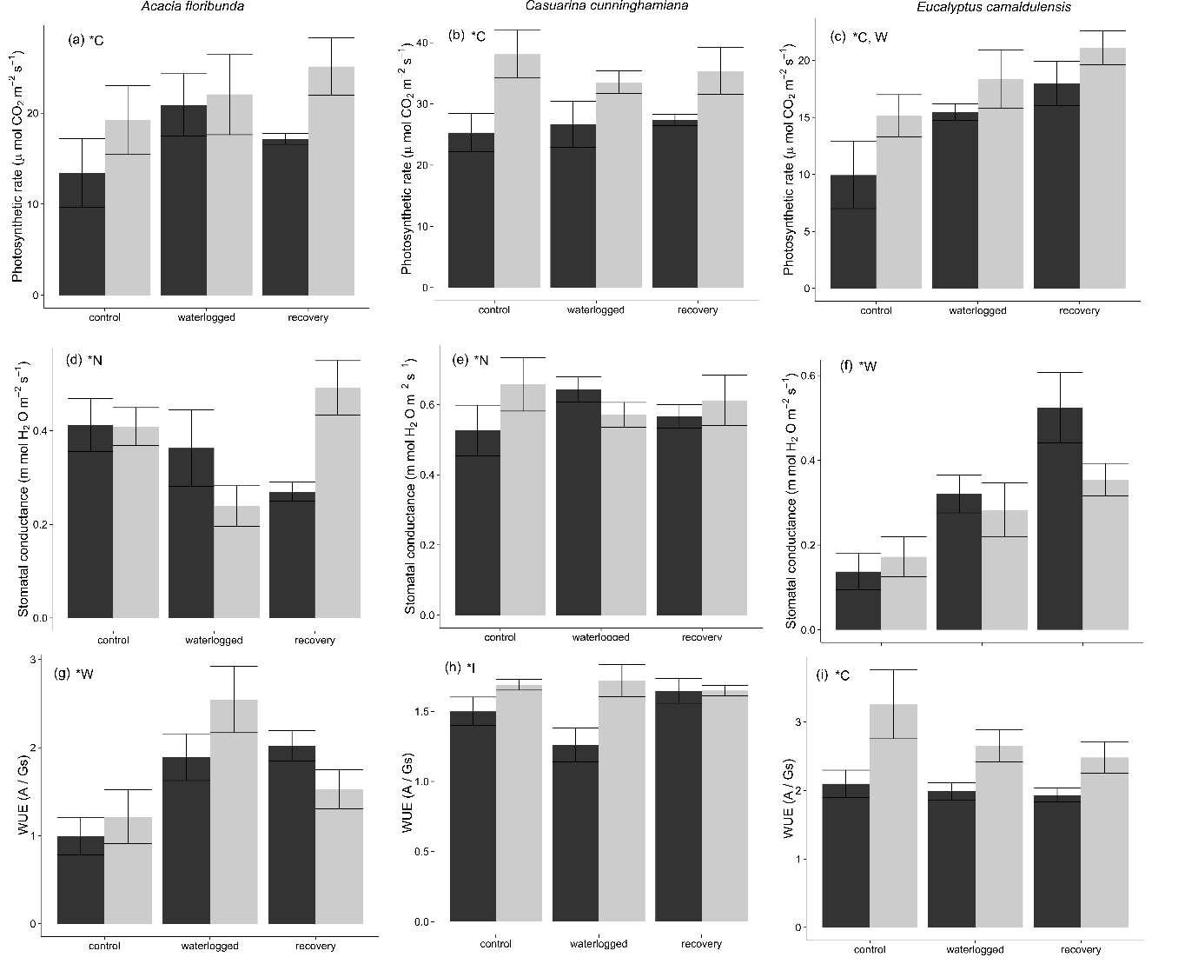

Figure . Gas exchange measurements under each combination of waterlogging and CO2 level treatments. Dark shaded columns represent measurements under ambient atmospheric CO2 concentration (390 ppm), light shaded columns represent measurements under elevated atmospheric CO2 concentration (550 ppm). Error bars represent the standardised mean error. * - letters denote statistical significance of differences between treatment combinations (N = no significant difference, C = significant difference between CO2 level treatments, W = significant difference between waterlogging treatments).

*Biomass production*

Waterlogging status and CO2 level interacted strongly for one species: eCO2 stimulation of biomass production in *C. cunninghamiana* was diminished following recovery from waterlogging.

Total root biomass of plants recovering from waterlogging was lower than control plants for *A. floribunda* (p = 0.028, Fig. 2a). A significant interaction effect was identified for *C. cunninghamiana* (p = 0.049): total root biomass was substantially increased under eCO2 for control (p = 0.011) but not recovery plants (Fig. 2b). Neither CO2 level nor waterlogging had an effect on total root biomass for *E. camaldulensis* (Fig. 2c).

Fine root biomass of *A. floribunda* was lower in recovery plants than control plants (p = 0.005), with no CO2 effect (Fig. 2d). A marginally significant interaction effect was also present for *C. cunninghamiana* fine root biomass (p = 0.076); post-hoc analysis confirmed that control but not recovery plants had significantly greater fine root biomass under eCO2 (p = 0.008) (Fig. 2e). Waterlogging stimulated fine root growth in *E. camaldulensis* (p = 0.046) but CO2 level had no effect (Fig. 2f).

Neither CO2 level nor waterlogging had any effect on shoot biomass for *A. floribunda* (Fig. 2g) or *E. camaldulensis* (Fig. 2i). As with total root biomass and fine root biomass, CO2 level and waterlogging influenced *C. cunninghamiana* biomass interactively (p = 0.009): shoot biomass was higher under eCO2 for control (p = 0.015) but not recovery plants (Fig. 2h).

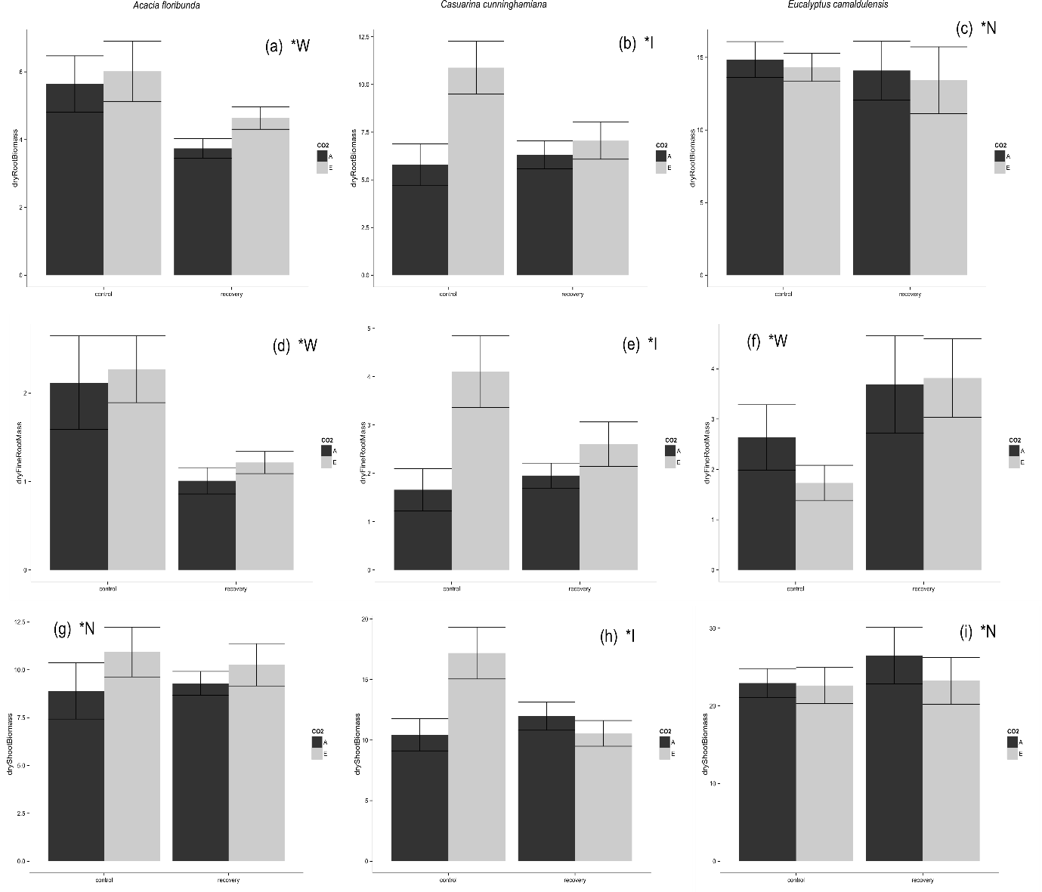

Figure 2. Biomass measurements under each combination of waterlogging and CO2 level treatments. Dark shaded columns represent measurements under ambient CO2 concentration (390 ppm), light shaded columns represent measurements under elevated CO2 concentration (550 ppm). Error bars represent the standardised mean error. * - letters denote statistical significance of differences between treatment combinations (N = no significant difference, C = significant difference between CO2 level treatments, W = significant difference between waterlogging treatments).

*Functional traits & biomass allocation*

We found no evidence to suggest that CO2 mediates biomass allocation or functional traits in response to waterlogging status.

Fine root dry matter content (fRDMC) was higher in waterlogged *A. floribunda* than recovery plants (p = 0.027), but not different between control and recovery or control and waterlogged plants. A marginally significant interaction effect was also present for *A. floribunda* (p = 0.067), but no differences were significant upon post-hoc analysis. Waterlogging status also affected *E. camaldulensis* fRDMC (Fig. 3b): control plants had higher fRDMC than waterlogged plants (p = 0.018), and recovery plants (p = 0.053) (marginally significant). eCO2 was associated with significantly increased fRDMC in *C. cunninghamiana* (p = 0.013, Fig. 3c), but waterlogging status had no effect.

Waterlogged *A. floribunda* had lower SLA than control (p = 0.001), and recovery plants (p < 0.0001) (Fig. 3 d). Waterlogged *E. camaldulensis* had higher SLA than control (p = 0.0013) and recovery plants (p = 0.0006) (Fig. 3f). Waterlogging status had no effect on *C. cunninghamiana* SLA (Fig. 3e). CO2 level had no effect on the SLA of any species.

Stem density in *C. cunninghamiana* was increased under elevated CO2 (p = 0.0177) (Fig. 3h). Stem density was lower in waterlogged *C. cunninghamiana* than control (p = 0.0167) or recovery plants (0.050) Neither CO2 nor waterlogging status had any effect on stem density of *A. floribunda* (Fig. 3g) or *E. camaldulensis* (3i).

Root mass fraction (RMF) was decreased by waterlogging for all species, but no significant CO2 or interaction effects were found. RMF of *A. floribunda* was lower in waterlogged than control plants (p < 0.0001), and lower in waterlogged than recovery plants (p < 0.0001). RMF of *A. floribunda* recovery plants was also lower than control plants (p = 0.016). RMF of both *C. cunninghamiana* and *E. camaldulensis* was lower in waterlogged than control plants (p < 0.0001), and lower in waterlogged than recovery plants (p < 0.0001), but there was no difference between recovery and control plants.

­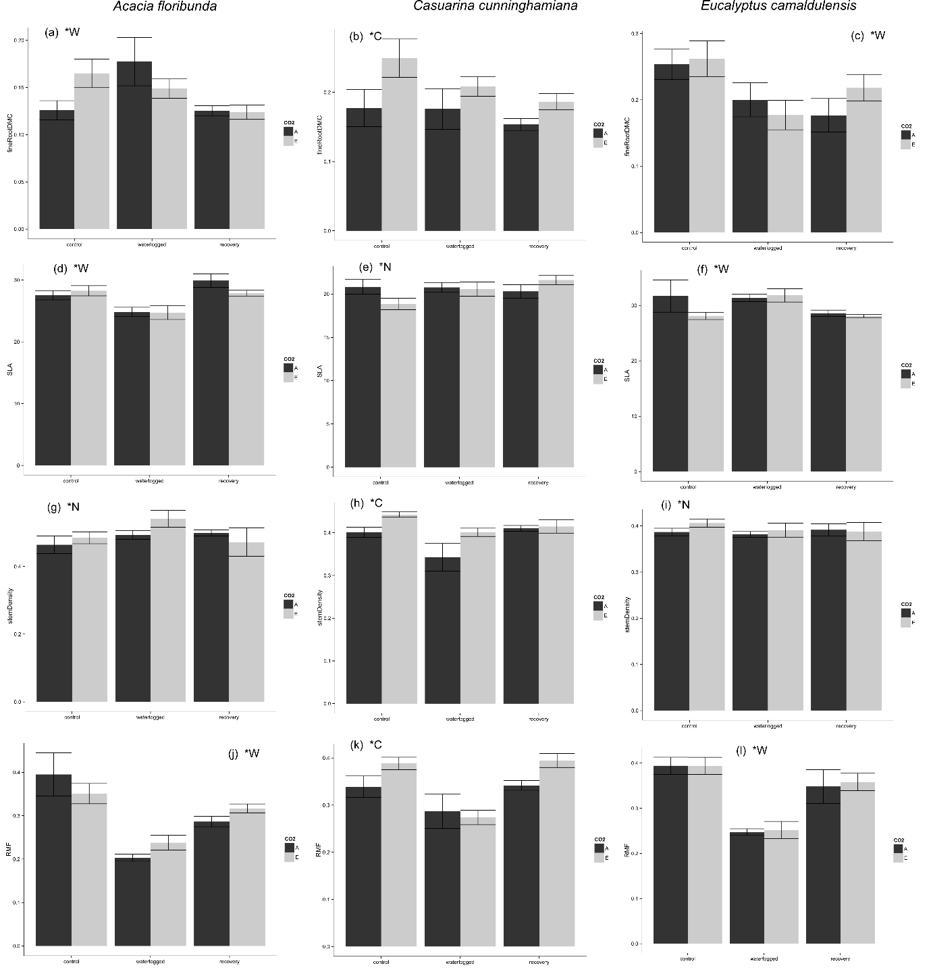

Figure 3. Functional trait measurements under each combination of waterlogging and CO2 level treatments. Dark shaded columns represent measurements under ambient CO2 concentration (390 ppm), light shaded columns represent measurements under elevated CO2 concentration (550 ppm). Error bars represent the standardised mean error. * - letters denote statistical significance of differences between treatment combinations (N = no significant difference, C = significant difference between CO2 level treatments, W = significant difference between waterlogging treatments).

DISCUSSION

We found inconsistent effects of atmospheric CO2 concentration and waterlogging status on growth, gas exchange and functional traits between species of riparian tree seedlings and no evidence for a consistent effect of elevated CO2 mediating plant responses to flooding.

While photosynthesis is the primary means by which plants accumulate biomass, increases in leaf-level photosynthesis may not necessarily translate to biomass gains. Metabolically costly responses to waterlogging tolerance, such as anaerobic catabolism, detoxification of reactive oxygen species and metal ions, and morphological adaptations such as formation of adventitious roots may act as energetic sinks (Colmer & Voesenek 2009). Relationships between photosynthetic rate and biomass responses to waterlogging and CO2 level treatments in this study varied widely between species.

For the three species studied here, only for *C. cunninghamiana* was an interactive effect found of CO2 concentration and waterlogging status. Biomass of shoot, total root and fine root components was significantly higher under eCO2 for control *C. cunninghamiana* plants, but not for plants which were recovering from waterlogging, despite increased rates of CO2 assimilation. No significant interaction effect on root mass fraction was found, but visual inspection of the data (Fig. 3k) indicates that eCO2 stimulation of RMF was present in control and recovering, but not waterlogged plants. Re-establishment of pre-waterlogging biomass allocation appears to have occurred despite no differences in total biomass. Photosynthesis remained higher in recovering plants under eCO2, indicating that their ability to convert the extra photosynthate produced under eCO2 into biomass was impaired by waterlogging.

No increase in biomass was associated with increased photosynthetic rate under eCO2 for either *A. floribunda* or *E. camaldulensis*. *A. floribunda* underwent substantial root mortality in response to waterlogging, although the presence of spongy white aerenchymous adventitious roots indicated a degree of morphological adaptation to anoxia (Evans 2004). Conversely, waterlogging stimulated fine root growth in *E. camaldulensis*. A proliferation of fine aerenchymous roots both below and above the water line was observed in waterlogged and recovered plants, corresponding to increased fine root mass compared with control plants. The strong morphological response of *E. camaldulensis* root systems combined with higher photosynthetic rate in recovering compared with control plants, and higher stomatal conductance in waterlogged plants than control or recovering plants, indicates that *E. camaldulensis* responded favourably to waterlogging in this study. This growth response concurs with the results of previous studies (Sena-Gomes & Kozlowski 1980; Marcar 1993, although see Kogawara *et al.* 2006).

No evidence was found to support the hypothesis that higher water use efficiency under eCO2 might facilitate photosynthesis where waterlogging had caused stomatal closure. WUE was altered by waterlogging only in *A. floribunda*, and by CO2 level only in *E. camaldulensis*. WUE was dependent on the combination of waterlogging status and CO2 level in *C. cunninghamiana*, being higher at eCO2 than aCO2 for waterlogged plants only. The lack of stomatal response to waterlogging indicates that higher WUE under eCO2 is not the mechanism maintaining photosynthetic rate under waterlogging for *C. cunninghamiana*.

Waterlogging and atmospheric CO2 level also altered functional traits in a species-specific manner, but no interactive effects were found. Traits of *A. floribunda* and *E. camaldulensis* were affected by waterlogging status but not CO2 level, whereas *C. cunninghamiana* was affected by CO2. Decreased SLA and increased fine root dry matter content – a proxy for fine root tissue density (Birouste *et al.* 2013) – in waterlogged *A. floribunda* indicate a shift towards the slower growth – longer life end of their respective economic spectra (Reich 2014), but this shift was not sustained following the refractory period. A corresponding pattern in water use efficiency corroborates this inference. Higher root dry matter content under waterlogging has been linked to the requirement for structural support of air spaces in aerenchymous root tissue (Ryser, Gill & Byrne 2011). Suberization of root hypodermal tissue often occurs under waterlogging as a means of reducing radial oxygen loss (Visser *et al.* 2000; De Simone *et al.* 2002) and may also increase root dry matter content. *E. camaldulensis* responded in an opposite manner, with higher SLA under waterlogging, and lower root dry matter content under waterlogging and after the refractory period. This species appears to employ an opportunistic ‘fast growth’ ecological strategy in response to waterlogging, involving proliferation of lower density roots, and lower carbon investment in leaf tissue (Wright *et al.* 2004; Reich 2014). We found no evidence for decreased SLA under eCO2 as previously described (Poorter & Navas 2003). Previous studies report inconsistent effects of eCO2 on fine root dry matter content in non-riparian species: eCO2 had no effect on *Liquidambar styraciflua or Pinus strobus* fRDMC(Bauer & Berntson 2001; Iversen, Ledford & Norby 2008), caused a small decrease in *Betula alleghaniensis* (Bauer & Berntson 2001) and increased fRDMC in cotton (Prior *et al.* 1994). In this study, eCO2 consistently increased fine root dry matter content in *C. cunninghamiana*.

Analysis of gas exchange, biomass accumulation and functional traits after a refractory period provided an opportunity to determine whether responses to waterlogging persisted or were transitory. We were unable to substantiate the hypothesis that eCO2 would increase the rate of biomass recovery from waterlogging by increasing the rate of fine root turnover. *C. cunninghamiana* was the only species for which eCO2 altered biomass accumulation, and depression of biomass was observed following the refractory period irrespective of CO2 level. Although we made no analysis of nodulation rates, nodulation of *C. cunninghamiana* by the nitrogen fixing ascomycete *Frankia* is known to be highest under well aerated soil conditions (Dawson *et al.* 1989). Reduced nitrogen uptake due to nodule mortality or impairment could account for the constrained biomass response to eCO2 post-waterlogging (Reich *et al.* 2006).

CONCLUSIONS

Waterlogging and atmospheric CO2 concentration both have significant consequences for physiological processes, growth and functional characteristics of riparian tree seedlings. The relative importance of these environmental factors varies according to species, as do the specific effects of each on plants. This study adds to the small but growing body of literature describing the interactive effects of waterlogging and CO2 concentration; notably, the outcome for *C. cunninghamiana* concurs with that found for *Taxodium distichum*, a flood tolerant colonist of alluvial riparian areas in the south eastern United States (Megonigal *et al.* 2005). Blunting of eCO2 biomass stimulation in seedlings by waterlogging has the potential to alter demographics and structural dynamics in many Australian riparian communities where *C. cunninghamiana* is a keystone species (Woolfrey & Ladd 2001).

ACKNOWLEDGEMENTS

We would like to acknowledge Urvashi Lallu and Claire Laws for their help in the glasshouses. This research was supported by Macquarie University and an Australian Postgraduate Award scholarship to JL.

REFERENCES

Ainsworth, E. a. & Rogers, A. (2007) The response of photosynthesis and stomatal conductance to rising [CO 2]: Mechanisms and environmental interactions. *Plant, Cell and Environment*, **30**, 258–270.

Arenque, B.C., Grandis, A., Pocius, O., de Souza, A.P. & Buckeridge, M.S. (2014) Responses of Senna reticulata, a legume tree from the Amazonian floodplains, to elevated atmospheric CO2 concentration and waterlogging. *Trees*, **28**, 1021–1034.

Bader, M.K.F., Siegwolf, R. & Körner, C. (2010) Sustained enhancement of photosynthesis in mature deciduous forest trees after 8 years of free air CO2 enrichment. *Planta*, **232**, 1115–1125.

Bailey-Serres, J. & Voesenek, L. a C.J. (2008) Flooding stress: acclimations and genetic diversity. *Annual review of plant biology*, **59**, 313–339.

Bauer, G. a & Berntson, G.M. (2001) Ammonium and nitrate acquisition by plants in response to elevated CO2 concentration: the roles of root physiology and architecture. *Tree Physiology*, **21**, 137–144.

Birouste, M., Zamora-Ledezma, E., Bossard, C., Pérez-Ramos, I.M. & Roumet, C. (2013) Measurement of fine root tissue density: a comparison of three methods reveals the potential of root dry matter content. *Plant and Soil*, **374**, 299–313.

Blom, C.W.P.M. & Voesenek, L.A.C.J. (1996) Flooding: the survival strategies of plants. *Trends in Ecology & Evolution*, **11**, 290–295.

Colmer, T.D. & Voesenek, L.A.C.J. (2009) Flooding tolerance: suites of plant traits in variable environments. *Functional Plant Biology*, **36**, 665–681.

Corenblit, D., Steiger, J., Gurnell, A.M., Tabacchi, E. & Roques, L. (2009) Control of sediment dynamics by vegetation as a key function driving biogeomorphic succession within fluvial corridors. *Earth Surface Processes and Landforms*, **1810**, 1790–1810.

Curtis, P.S. (1996) A meta-analysis of leaf gas exchange and nitrogen in trees grown under elevated carbon dioxide. *Plant, Cell and Environment*, **19**, 127–137.

Dawson, J.O., Kowalski, D.G. & Dart, P.J. (1989) Variation with soil depth, topographic position and host species in the capacity of soils from an Australian locale to nodulate Casuarina and Allocasuarina seedlings. *Plant and Soil*, **118**, 1–11.

Drew, M.C. (1997) OXYGEN DEFICIENCY AND ROOT METABOLISM: Injury and Acclimation Under Hypoxia and Anoxia. *Annual Review of Plant Physiology and Plant Molecular Biology*, **48**, 223–250.

Else, M. a., Janowiak, F., Atkinson, C.J. & Jackson, M.B. (2009) Root signals and stomatal closure in relation to photosynthesis, chlorophyll a fluorescence and adventitious rooting of flooded tomato plants. *Annals of Botany*, **103**, 313–323.

Evans, D.E. (2004) Aerenchyma formation. *New Phytologist*, **161**, 35–49.

Gurnell, A.M., Bertoldi, W. & Corenblit, D. (2012) Changing river channels: The roles of hydrological processes, plants and pioneer fluvial landforms in humid temperate, mixed load, gravel bed rivers. *Earth-Science Reviews*, **111**, 129–141.

Gutschick, V.P. & BassiriRad, H. (2003) Extreme events as shaping physiology, ecology, and evolution of plants: toward a unified definition and evaluation of their consequences. *New Phytologist*, **160**, 21–42.

Holtum, J. a M. & Winter, K. (2010) Elevated [CO2] and forest vegetation: More a water issue than a carbon issue? *Functional Plant Biology*, **37**, 694–702.

Iversen, C.M., Ledford, J. & Norby, R.J. (2008) CO2 enrichment increases carbon and nitrogen input from fine roots in a deciduous forest. *New Phytologist*, **179**, 837–847.

Keenan, T.F., Hollinger, D.Y., Bohrer, G., Dragoni, D., Munger, J.W., Schmid, H.P. & Richardson, A.D. (2013) Increase in forest water-use efficiency as atmospheric carbon dioxide concentrations rise. *Nature*, **499**, 324–7.

Kogawara, S., Yamanoshita, T., Norisada, M., Masumori, M. & Kojima, K. (2006) Photosynthesis and photoassimilate transport during root hypoxia in Melaleuca cajuputi, a flood-tolerant species, and in Eucalyptus camaldulensis, a moderately flood-tolerant species. *Tree physiology*, **26**, 1413–1423.

Körner, C. (2006) Plant CO2 responses: An issue of definition, time and resource supply. *New Phytologist*, **172**, 393–411.

Kozlowski, T.T. (1984) Responses of woody plants to flooding. *Flooding and Plant Growth* (ed T. Kozlowski), pp. 129–163. Academic Press, San Diego.

Lipson, D. a., Kuske, C.R., Gallegos-Graves, L.V. & Oechel, W.C. (2014) Elevated atmospheric CO2 stimulates soil fungal diversity through increased fine root production in a semiarid shrubland ecosystem. *Global Change Biology*, **20**, 2555–2565.

Manea, A. & Leishman, M.R. (2014) Competitive interactions between established grasses and woody plant seedlings under elevated CO2 levels are mediated by soil water availability. *Oecologia*, **177**, 499–506.

Marcar, N.E. (1993) Waterlogging Modifies Growth, Water Use and Ion Concentrations in Seedlings of Salt-treated Eucalyptus camaldulensis, E. tereticornis, E. robusta and E. globulus. *Australian Journal of Plant Physiology*, **20**, 1–13.

Matamala, R. & Schlesinger, W.H. (2000) Effects of elevated atmospheric CO2 on fine root production and activity in an intact temperate forest ecosystem. *Global Change Biology*, **6**, 967–979.

Megonigal, J., Vann, C. & Wolf, A. (2005) Flooding constraints on tree (Taxodium distichum) and herb growth responses to elevated CO2. *Wetlands*, **25**, 430–438.

Naiman, R., Decamps, H. & Pollock, M. (1993) The role of riparian corridors in maintaining regional biodiversity. *Ecological Applications*, **3**, 209–212.

Nie, M., Lu, M., Bell, J., Raut, S. & Pendall, E. (2013) Altered root traits due to elevated CO2: A meta-analysis. *Global Ecology and Biogeography*, **22**, 1095–1105.

Piedade, M.T.F., Ferreira, C.S., Wittmann, A.D.O., Buckeridge, M. & Parolin, P. (2010) Amazonian Floodplain Forests - Springer. (ed W. Junk),.

Poorter, L. (2007) Are species adapted to their regeneration niche, adult niche, or both? *The American Naturalist*, **169**, 433–442.

Poorter, H. & Navas, M.L. (2003) Plant growth and competition at elevated CO2: on winners, losers and functional groups. *New Phytologist*, **157**, 175–198.

Pregitzer, K.S., Zak, D.R., Curtis, P.S., Kubiske, M.E., Teeri, J. a & Vogel, C.S. (1995) Atmospheric CO2, soil-nitrogen and Turnover of fine roots. *New Phytologist*, **129**, 579–585.

Pregitzer, K., Zak, D., Maziasz, J., DeForest, J., Curtis, P. & Lussenhop, J. (2000) Interactive effects of atmospheric CO2 and soil-N availability on fine roots of populus tremuloides. *Ecological Applications*, **10**, 18–33.

Prior, S.A., Rogers, H.H., Runion, G.B. & Hendrey, G.R. (1994) Free-air CO2 enrichment of cotton: vertical and lateral root distribution patterns. *Plant and Soil*, **165**, 33–44.

R Core Team. (2013) R: A Language and Environment for Statistical Computing.

Reich, P.B. (2014) The world-wide “fast-slow” plant economics spectrum: A traits manifesto. *Journal of Ecology*, **102**, 275–301.

Reich, P.B., Hobbie, S.E. & Lee, T.D. (2014) Plant growth enhancement by elevated CO2 eliminated by joint water and nitrogen limitation. *Nature Geoscience*, **7**, 1–5.

Reich, P.B., Hobbie, S.E., Lee, T., Ellsworth, D.S., West, J.B., Tilman, D., Knops, J.M.H., Naeem, S. & Trost, J. (2006) Nitrogen limitation constrains sustainability of ecosystem response to CO2. *Nature*, **440**, 922–925.

Ryser, P., Gill, H.K. & Byrne, C.J. (2011) Constraints of root response to waterlogging in Alisma triviale. *Plant and Soil*, **343**, 247–260.

Santosa, I.E., Ram, P.C., Boamfa, E.I., Laarhoven, L.J.J., Reuss, J., Jackson, M.B. & Harren, F.J.M. (2007) Patterns of peroxidative ethane emission from submerged rice seedlings indicate that damage from reactive oxygen species takes place during submergence and is not necessarily a post-anoxic phenomenon. *Planta*, **226**, 193–202.

Sena-Gomes, A. & Kozlowski, T.T. (1980) Effects of flooding on Eucalyptus camaldulensis and Eucalyptus globulus seedlings. *Oecologia*, **46**, 139–142.

Shimono, H., Konno, T., Sakai, H. & Sameshima, R. (2012) Interactive Effects of Elevated Atmospheric CO2 and Waterlogging on Vegetative Growth of Soybean (Glycine max (L.) Merr.). *Plant Production Science*, **15**, 238–245.

De Simone, O., Haase, K., Müller, E., Junk, W.J., Gonsior, G. & Schmidt, W. (2002) Impact of root morphology on metabolism and oxygen distribution in roots and rhizosphere from two Central Amazon floodplain tree species. *Functional Plant Biology*, **29**, 1025–1035.

Van der Sleen, P., Groenendijk, P., Vlam, M., Anten, N.P.R., Boom, A., Bongers, F., Pons, T.L., Terburg, G. & Zuidema, P. a. (2014) No growth stimulation of tropical trees by 150 years of CO2 fertilization but water-use efficiency increased. *Nature Geoscience*, **8**, 24–28.

Steffens, B., Steffen-Heins, A. & Sauter, M. (2013) Reactive oxygen species mediate growth and death in submerged plants. *Frontiers in Plant Science*, **4**, 179.

Steudle, E. (2000) Water uptake by roots: an integration of views. *Plant Soil*, **226**, 45–56.

Stocker, T.F., Qin, D., Plattner, G.-K., Tignor, M., Allen, S.K., Boschung, J., Nauels, A., Xia, Y., Bex, V., Midgley, P.M. & others. (2013) *Climate Change 2013. The Physical Science Basis. Working Group I Contribution to the Fifth Assessment Report of the Intergovernmental Panel on Climate Change-Abstract for Decision-Makers*.

Visser, E.J.W., Colmer, T.D., Blom, C.W.P.M. & Voesenek, L. a C.J. (2000) Changes in growth, porosity, and radial oxygen loss from adventitious roots of selected mono- and dicotyledonous wetland species with contrasting types of aerenchyma. *Plant, Cell and Environment*, **23**, 1237–1245.

Voesenek, L.A.C.J. & Bailey-Serres, J. (2015) Flood adaptive traits and processes: an overview. *New Phytologist*, **206**, 57–73.

Wang, D., Heckathorn, S. a., Wang, X. & Philpott, S.M. (2012) A meta-analysis of plant physiological and growth responses to temperature and elevated CO2. *Oecologia*, **169**, 1–13.

Wang, X. & Taub, D.R. (2010) Interactive effects of elevated carbon dioxide and environmental stresses on root mass fraction in plants: A meta-analytical synthesis using pairwise techniques. *Oecologia*, **163**, 1–11.

Woolfrey, A.R. & Ladd, P.G. (2001) Habitat preference and reproductive traits of a major Australian riparian tree species (Casuarina cunninghamiana). *Australian Journal of Botany*, **49**, 705–715.

Wright, I.J., Reich, P.B., Westoby, M., Ackerly, D.D., Baruch, Z., Bongers, F., Cavender-bares, J., Chapin, T., Cornelissen, J.H.C., Diemer, M., Flexas, J., Garnier, E., Groom, P.K. & Gulias, J. (2004) The worldwide leaf economics spectrum. *Nature*, **428**, 821–827.